Practical - 3
Practical Title: Responsive UI Design using CSS Grid, Flexbox, and Bootstrap/Tailwind

Design responsive layouts for Home, About, Registration, Dashboard, and Events pages using CSS Grid and Flexbox. Optional to use CSS framework such as Bootstrap or Tailwind. Ensure mobile-first responsiveness.

Theory
1. How does the layout adapt for mobile, tablet, and desktop screens?
Mobile: The layout changes to a single-column structure. Navigation items, cards, forms, images, and other content are stacked vertically so they fit the smaller screen.
Tablet: The layout uses a moderate-width arrangement. Some elements can remain side-by-side, while larger sections are adjusted to fit the available space.
Desktop: The page uses the full available width, allowing elements such as navigation, sidebar, cards, and content sections to appear side-by-side.
Images and containers: Flexible widths such as width: 100% and max-width: 100% help prevent content from overflowing on smaller screens.
Media queries: CSS rules such as @media (max-width: 768px) can change widths, font sizes, spacing, navigation, and column layouts when the screen becomes smaller.
A responsive page should also include the viewport setting:
Reference Link: Responsive Web Design - GeeksforGeeks

2. Which layout technique is used and why?
For the Student Hub website, the main layout technique used is CSS Flexbox, with CSS Grid useful for sections such as dashboard cards and calendar-style layouts.

Flexbox is suitable for arranging elements such as the header, navigation bar, sidebar, and main content because it makes it easy to align elements horizontally or vertically and adjust them when the screen size changes. GeeksforGeeks describes Flexbox as a layout system for creating flexible and responsive layouts.

CSS Grid can be used where the page needs a structured two-dimensional arrangement, such as multiple dashboard cards or a calendar. GeeksforGeeks identifies Grid as useful for complex 2D layouts.

Why it is used:
- Provides a clean and organized page structure.
- Makes alignment of header, navbar, sidebar, and content easier.
- Allows elements to resize and reposition according to screen size.
- Supports responsive design when combined with media queries.
- Reduces the need for fixed positioning.

Reference Link: Responsive Web Design - GeeksforGeeks

3. Are typography, spacing, colors, and contrast readable?
Typography
The typography is readable because headings and body text are separated clearly, making the content easy to understand. A consistent font style and appropriate font size should be maintained throughout all pages. Proper line spacing also improves readability. GeeksforGeeks explains that typography readability depends on factors such as font choice, line spacing, contrast, and line length
Spacing
The spacing between the header, navigation bar, content sections, forms, and buttons should be consistent. Proper spacing prevents the page from looking crowded and makes it easier for users to follow the content. CSS margin controls outer spacing, while padding controls the space inside an element.
Colours
The colors should be simple and consistent throughout the Student Hub website. A limited colour palette makes the interface cleaner and avoids visual confusion. Important buttons, links, and headings can use accent colors to attract attention.
Contrast
The contrast between text and its background should be high enough so that the content is easily readable. Dark text on a light background or light text on a sufficiently dark background generally provides better readability. Good colour contrast is also an important part of accessible web design
Reference Link : What is Typography? - GeeksforGeeks

4. Is the framework used consistently without unnecessary inline CSS?
Yes. The framework is used consistently across all the HTML pages. The common structure such as the header, navigation bar, main content area, and footer is maintained throughout the website.
The styling is kept separate from the HTML using an external CSS file, instead of repeatedly writing CSS inside individual HTML elements. This makes the website easier to maintain and keeps the code clean.
External CSS is preferred when the same styles need to be applied to multiple pages, while inline CSS should be avoided when it is not necessary. GeeksforGeeks explains the different approaches of using inline, internal, and external CSS.
Reference Link: CSS Tutorial - GeeksforGeeks

Implementation/ Output/Result

My learning codes: https://drive.google.com/file/d/1CPP3uUq3gdKZxC3pFB7iheZVU7FCImSx/view?usp=drive_link

Evidence of Work (Screenshots)
Home page:
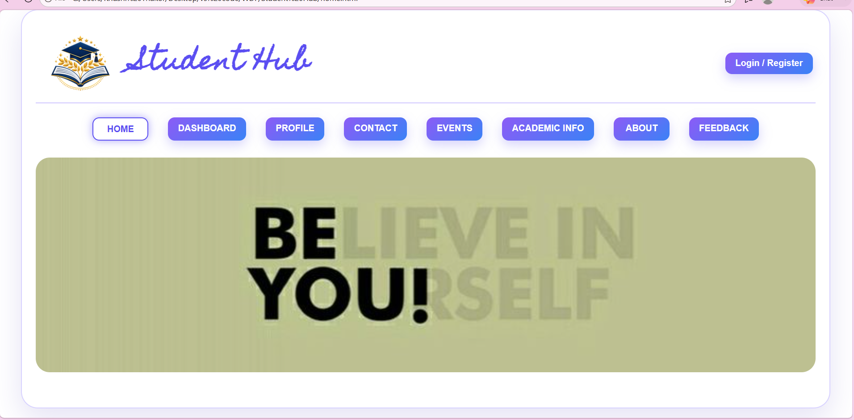

Register page:
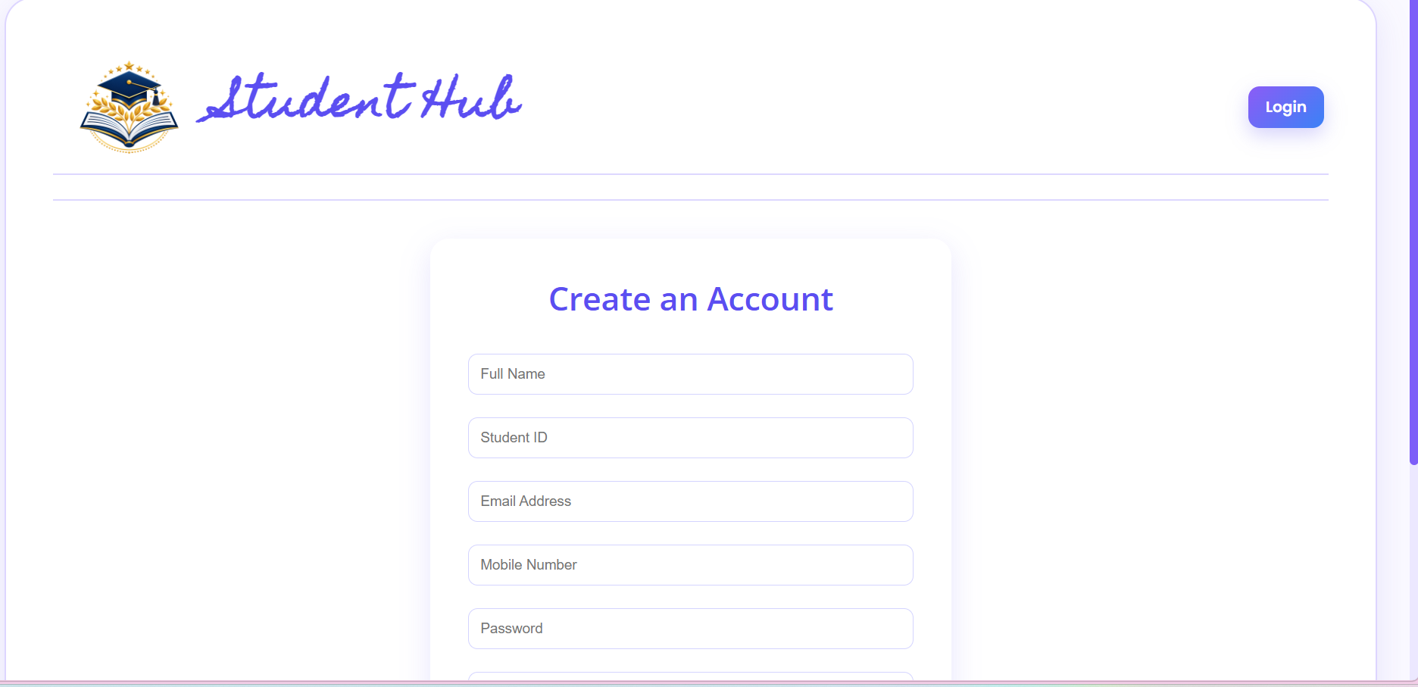
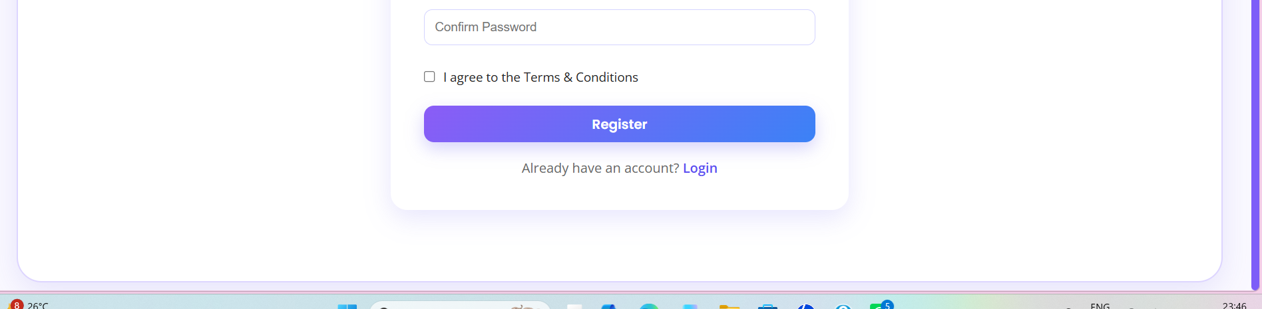
Login page:
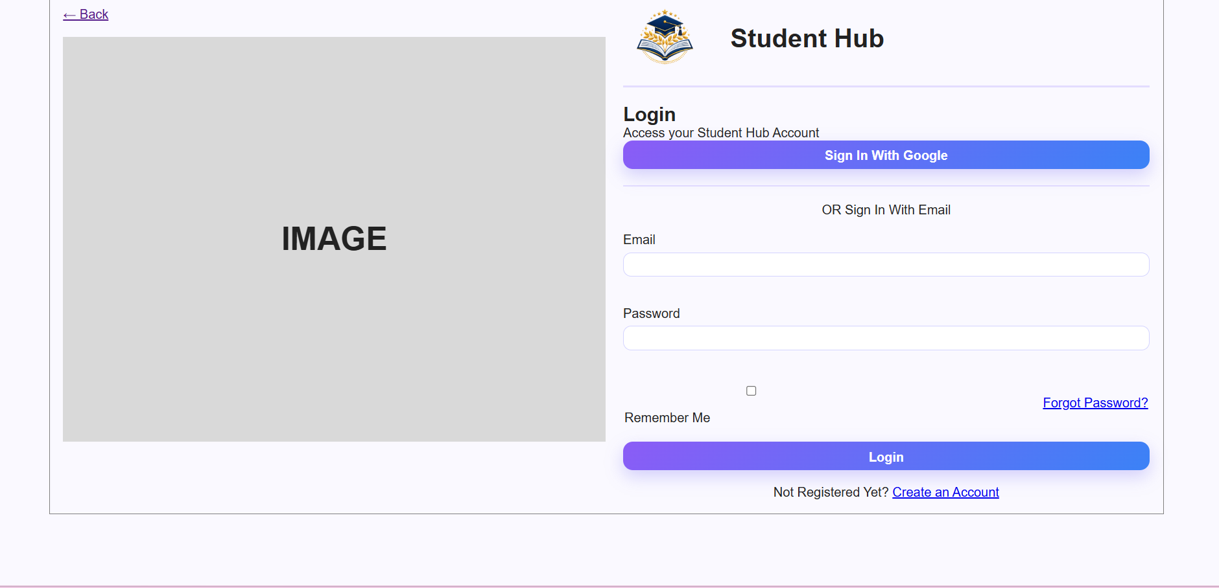
Dashboard:
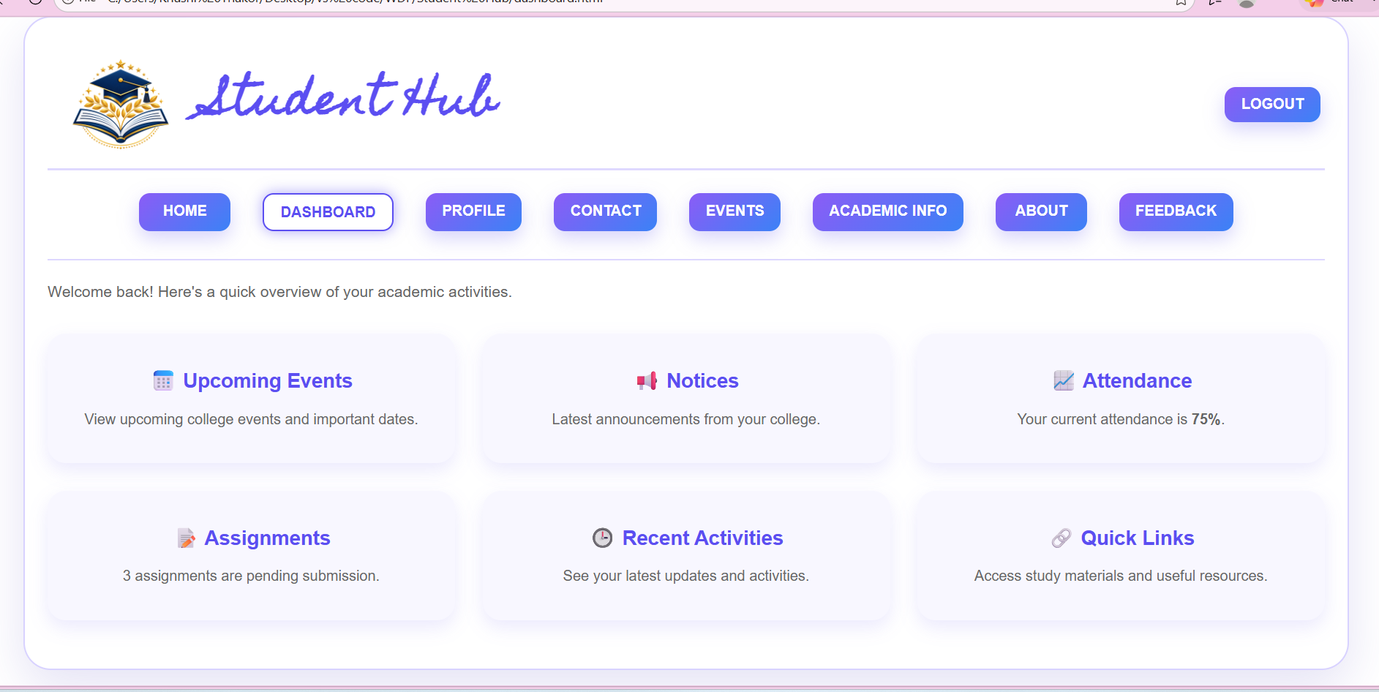
Profile:
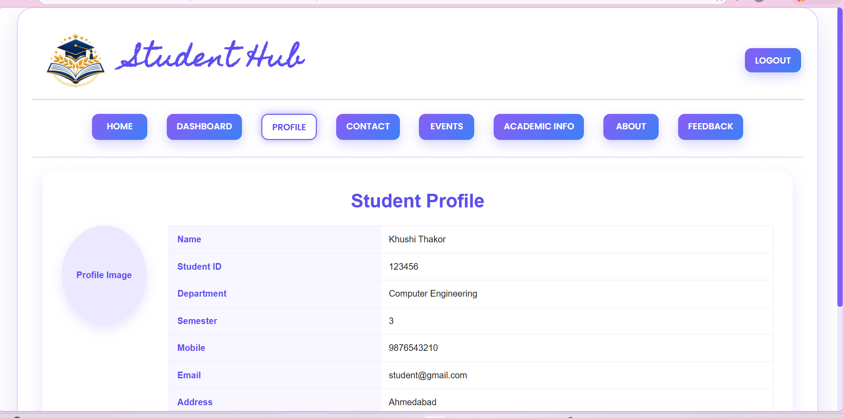
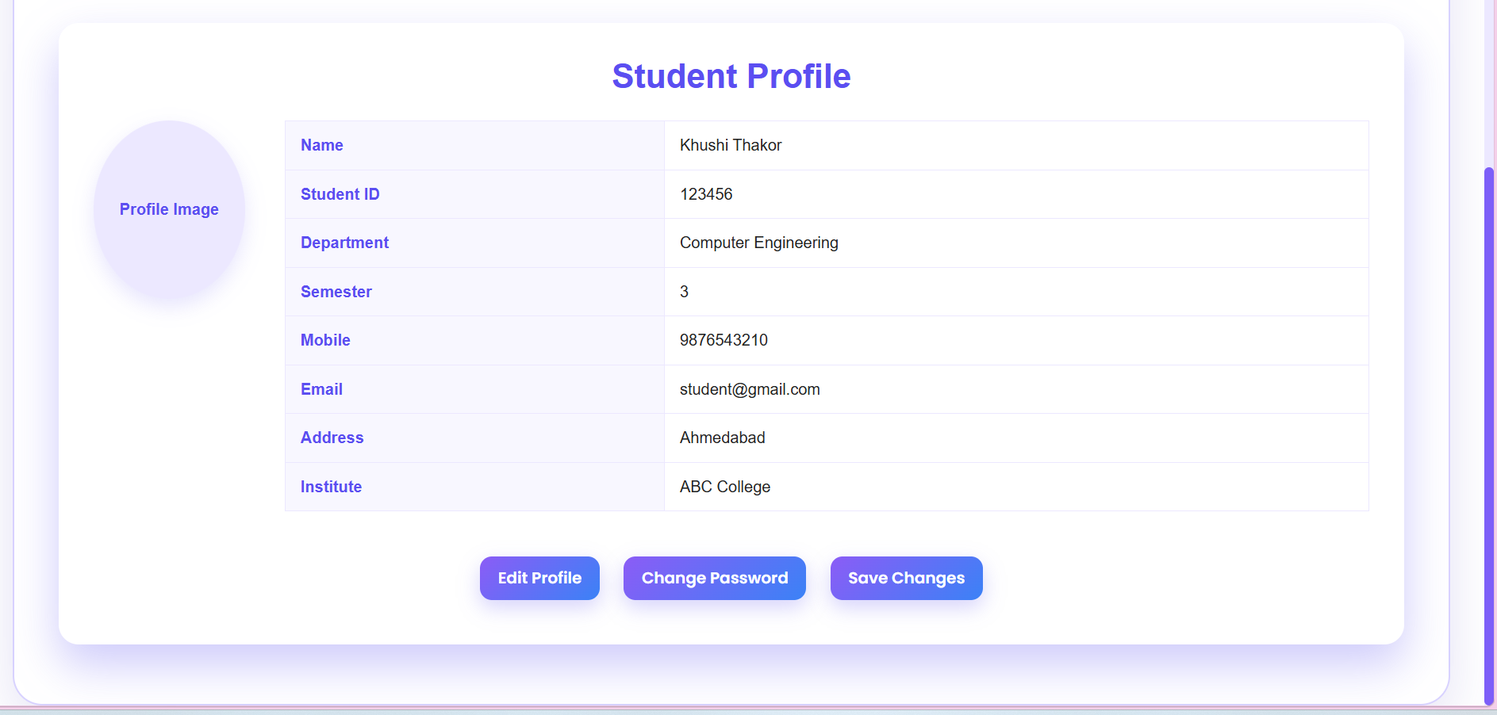
Contact:
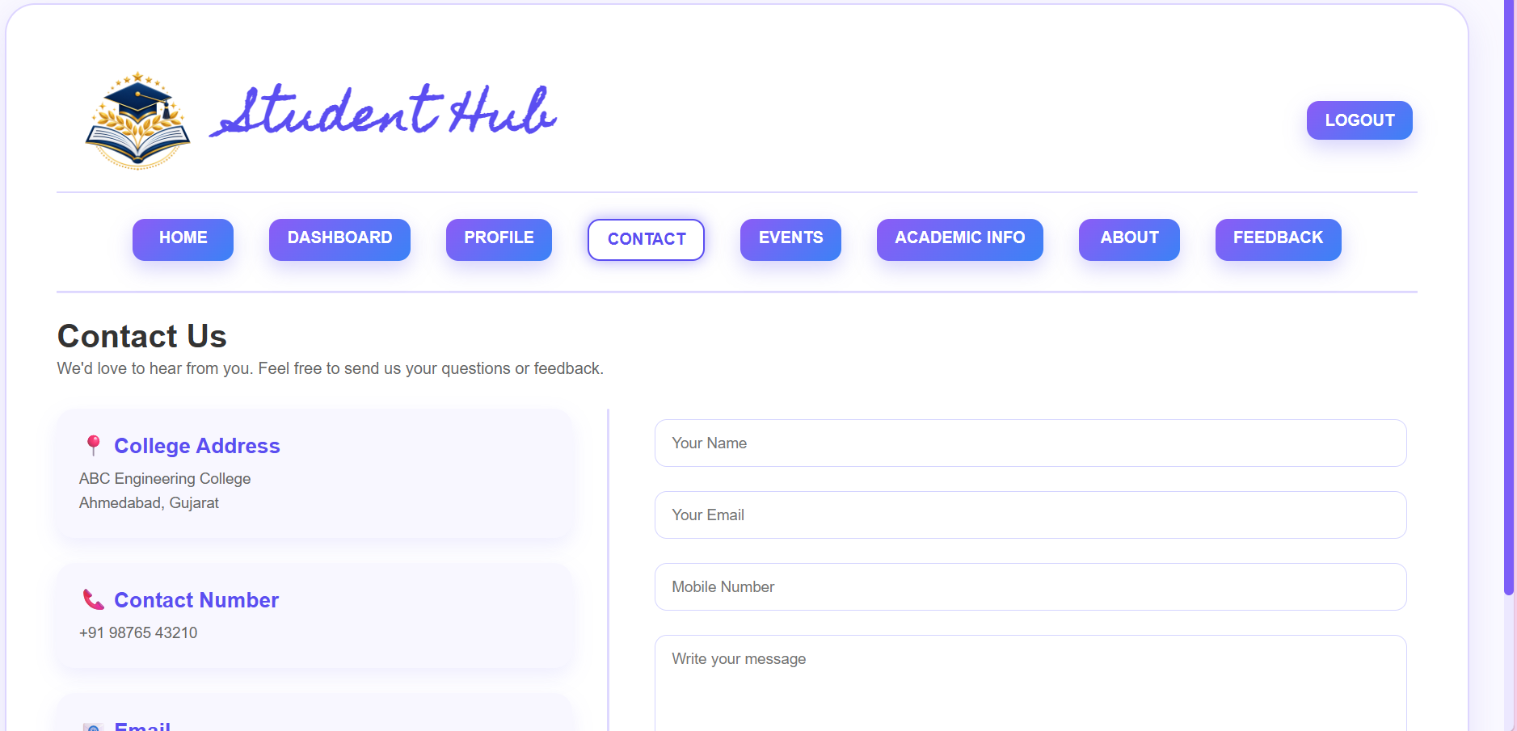
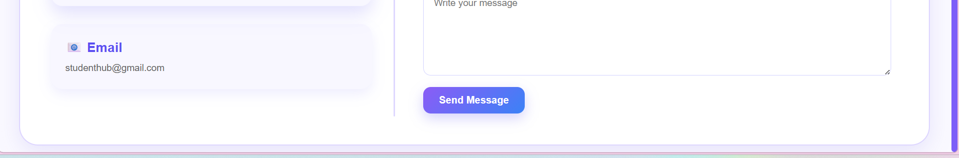

Event:
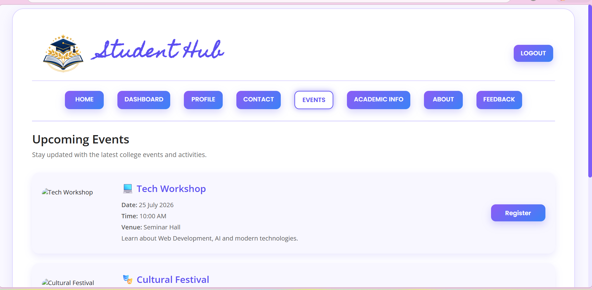
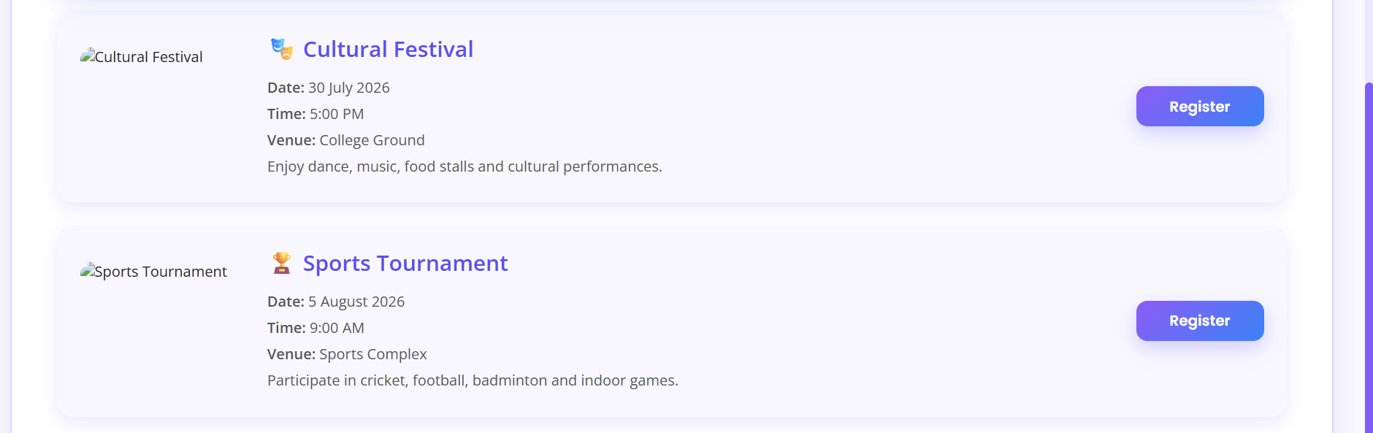
Academic page:
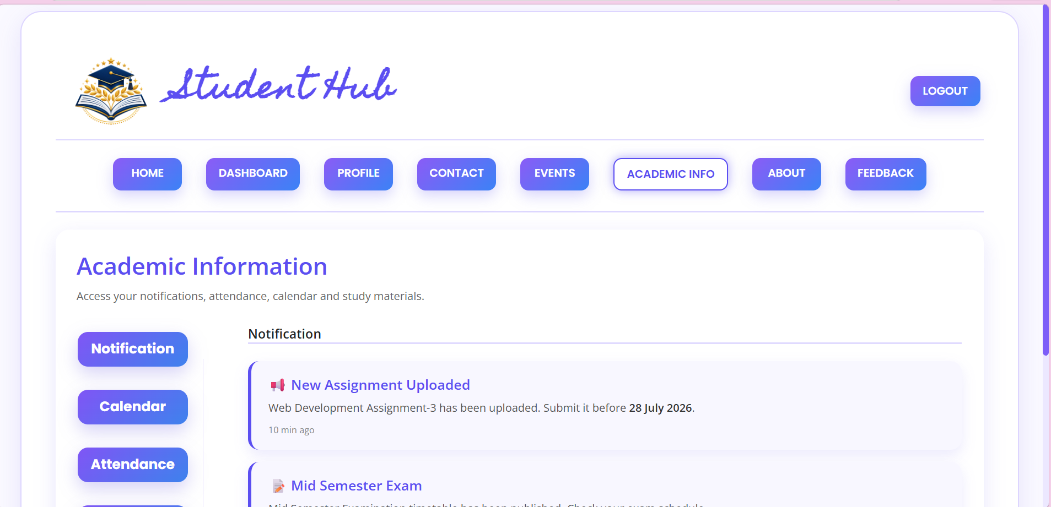
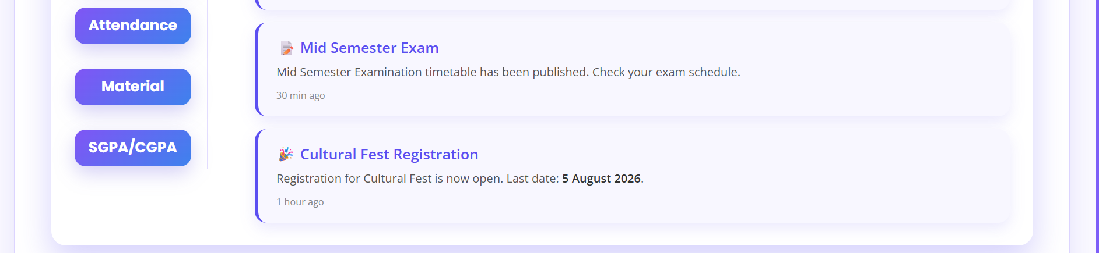
Attendance Page:
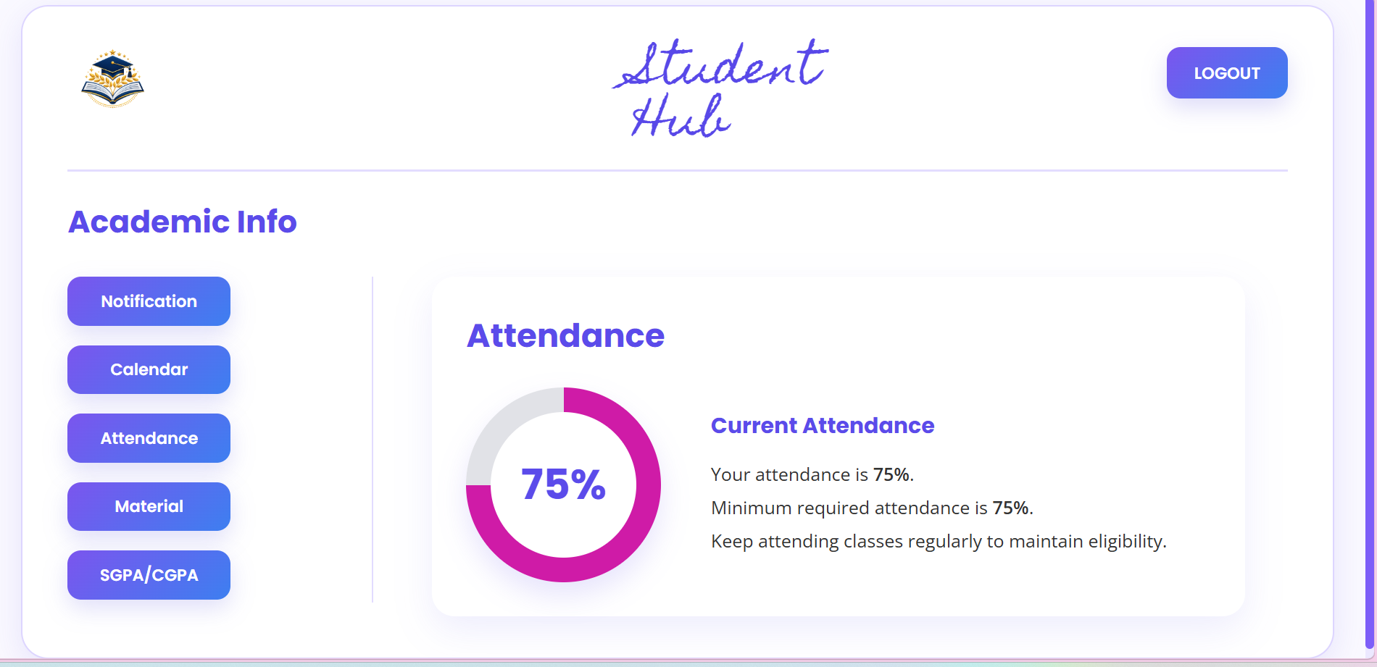
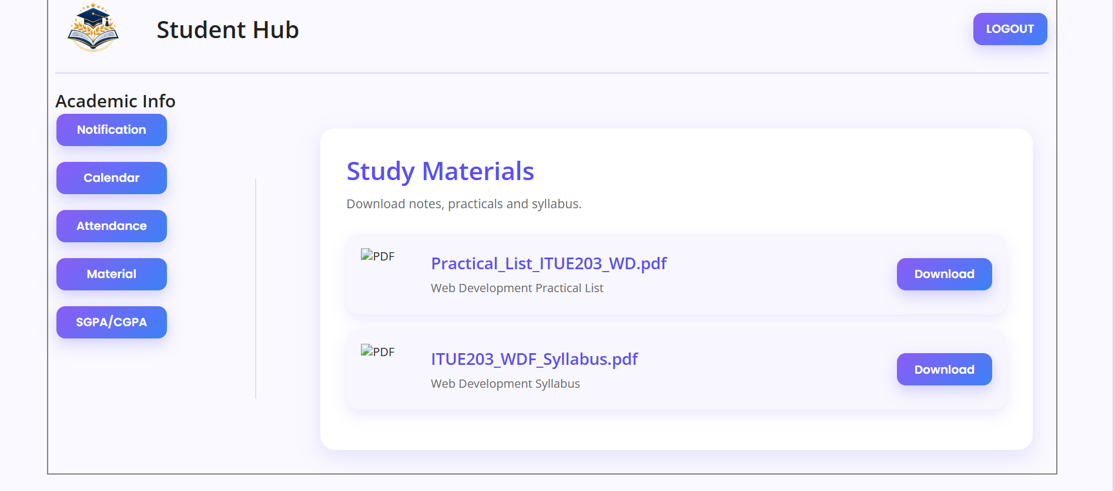
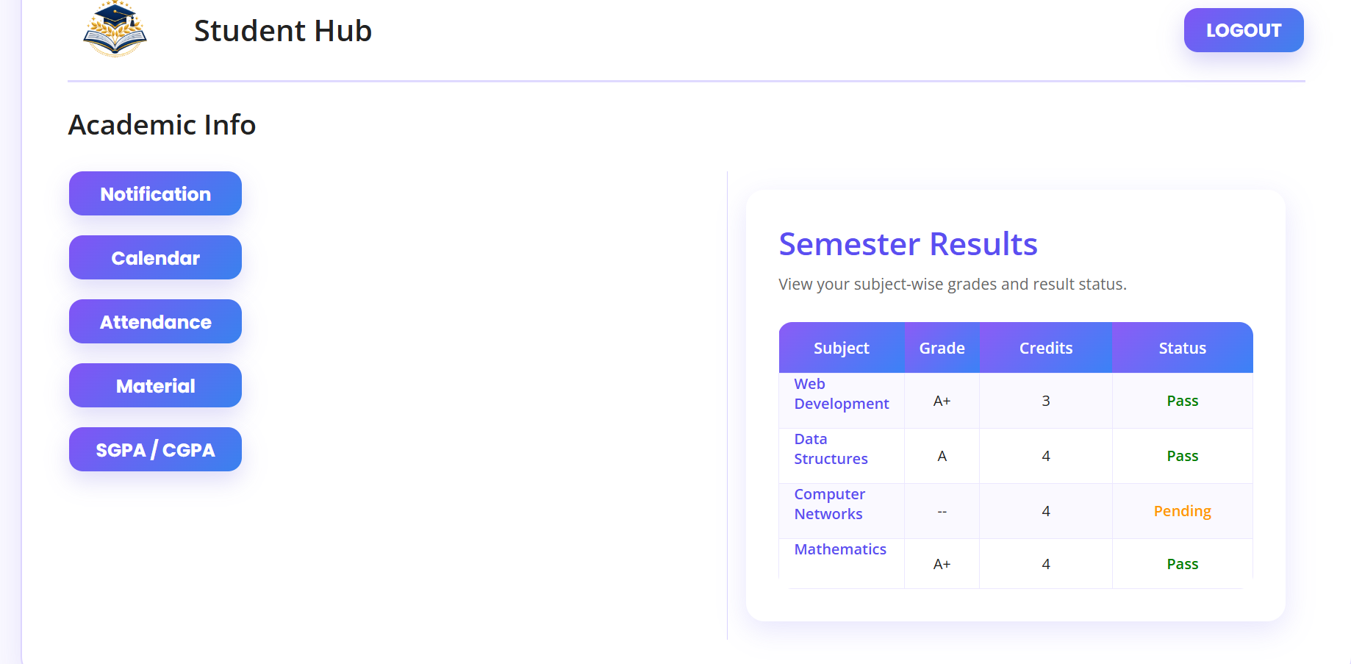
About page:
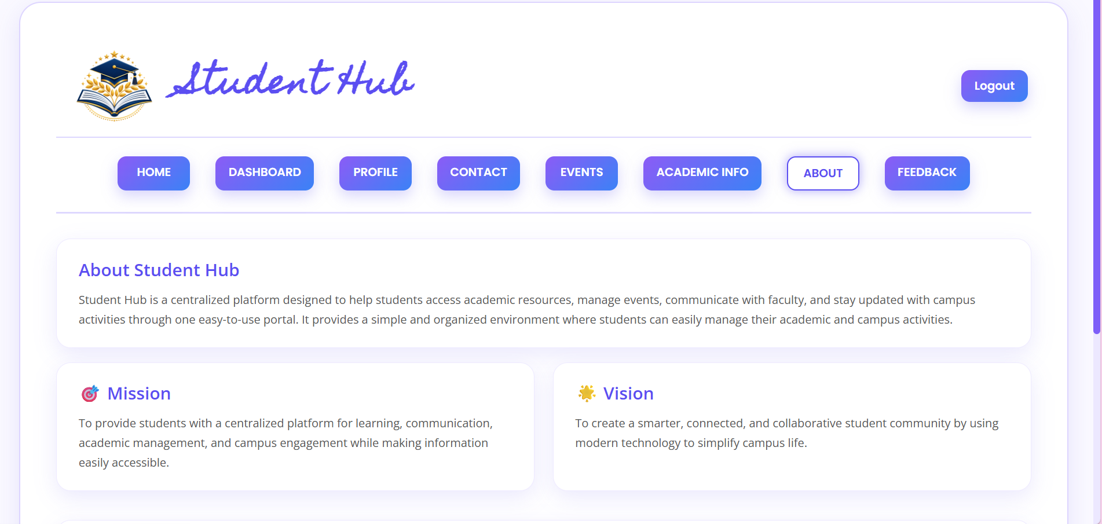
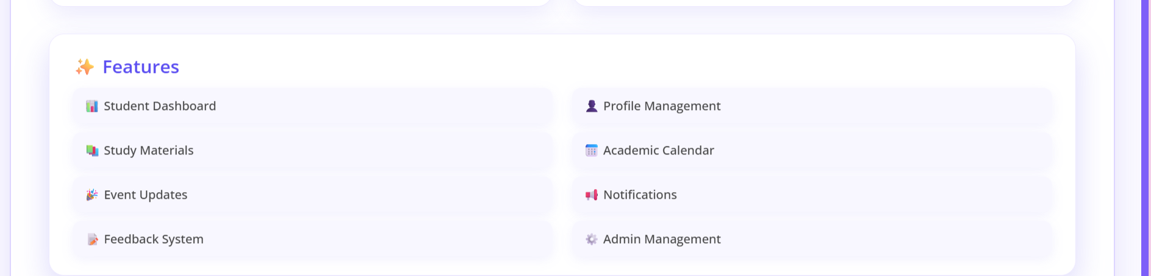
Feedback page:
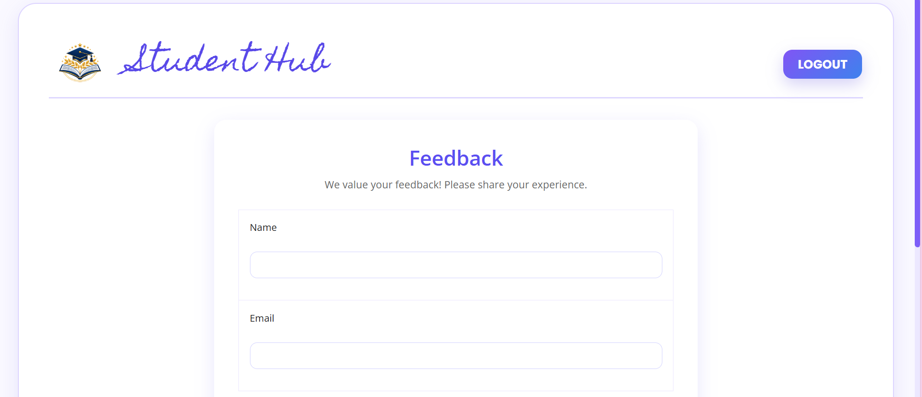
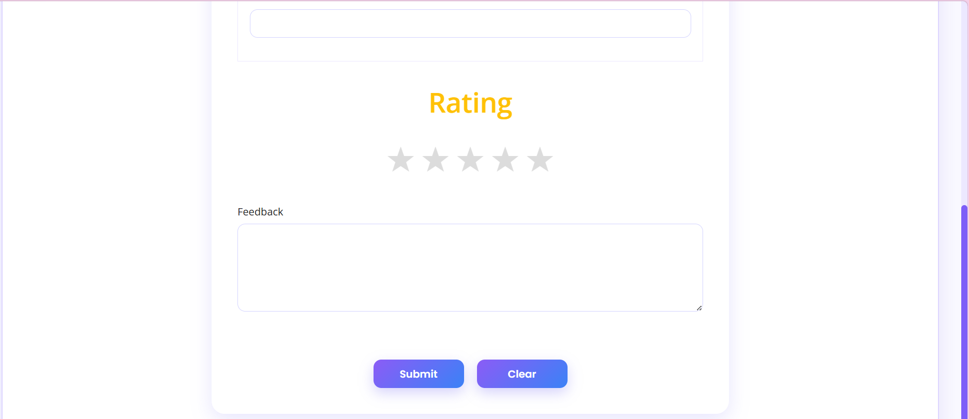

GitHub Repository Link:
Khushi-Thakor2007/Student-Hub-Portal

Challenges Faced:
The problem which I faced while making my web pages is applying different effects and give a hover and also border and slide window .

Learning Outcomes:

Students will design a professional, responsive, and reusable UI layout.

Faculty Remarks:

/* =====================================
ATTENDANCE PAGE
===================================== */

/* Attendance Card */

.attendance-card{

background:#ffffff;
border-radius:20px;
padding:30px;
margin:20px;
box-shadow:0 10px 30px rgba(91,78,241,.15);

transition:all .35s ease;

}

.attendance-card:hover{

box-shadow:0 22px 45px rgba(91,78,241,.30);

}

/* Heading */

.attendance-card h2{

color:#5B4EF1;
font-size:30px;
margin-bottom:25px;

transition:.35s ease;

}

.attendance-card:hover h2{

color:#3B82F6;

letter-spacing:1px;

}

/* Layout */

.attendance-content{

display:flex;
align-items:center;
gap:50px;

}

/* Circle */

.attendance-circle{

width:180px;
height:180px;

border-radius:50%;

background:conic-gradient(
#c522a5 0% 75%,
#e5e7eb 75% 100%
);

display:flex;
justify-content:center;
align-items:center;

position:relative;

box-shadow:0 15px 35px rgba(91,78,241,.25);

transition:all .4s ease;

cursor:pointer;

}

.attendance-circle:hover{

transform:scale(1.08) rotate(6deg);

box-shadow:0 25px 50px rgba(197,34,165,.45);

}

/* White Center */

.attendance-circle::before{

content:"";

position:absolute;

width:135px;
height:135px;

background:white;

border-radius:50%;

}

/* Percentage */

.attendance-circle span{

position:relative;
z-index:2;

font-size:38px;
font-weight:bold;
color:#5B4EF1;

transition:.35s ease;

}

.attendance-circle:hover span{

transform:scale(1.15);

color:#c522a5;

}

/* Details */
.attendance-details h3{

color:#5B4EF1;
margin-bottom:15px;

transition:.35s;

}

.attendance-card:hover .attendance-details h3{

color:#3B82F6;

}

.attendance-details p{

font-size:17px;
color:#555;
line-height:1.8;

}

